**NATIONAL ACADEMY OF SCIENCE AND TECHNOLOGY**



A Project Report On

**THE LIFE OF KING BIRENDRA AND HIS CONTRIBUTION FOR NEPAL**



Submitted To: Submitted By:

Mr. Upendra Bahadur Bam Amrit Pant

Class 11 (2022)

Section F

**ACKNOWLEDGEMENT**

I want to express my special Gratitude to **Mr. Upendra Bam sir** who gave me this opportunity to present a report on **THE LIFE OF KING BIRENDRA AND HIS CONTRIBUTION FOR NEPAL**. I want to extend my gratitude to my parents who supported and motivated me while doing the Project. I want to thank my friends Ritik Chand, Prasab Kunwar, and Ashish Chand who helped me to finish this report within a limited time. I have also taken some references from websites that are mentioned on the last page.

THANKS TO THE EVERYBODY WHO HELPED ME WITH THIS PRO**J**ECT

Amrit Pant

**Certificate of Completion** 

This is to certify that this Project is made by **Amrit Pant** a student of **Class 11 (Section F).** From the **National Academy of Science and Technology** on the topic of **THE LIFE OF KING BIRENDRA AND HIS CONTRIBUTION FOR NEPAL.** Under the guidance of **Mr. Upendra Bahadur Bam** and have been completed.

**Mr.Upendra Bam Mr. Krishna Bhandari**

**Lecturer of English Lecturer of Chemistry**

**Principle, NAST HOD, Science**

**Table of Contents**

1. King Birendra and his life …………………………………...5
2. The positive side of King Birendra ……..……….…………6
3. The Dark side of King Birednra…….…..……………………7
4. Conclusion………………………………...…………………...9
5. References …………………..………………………………..11

## **Introduction:**

Birendra was born at the Narayanhiti Royal Palace in Kathmandu as the eldest son of the then Crown Prince Mahendra Bir Bikram Shah Dev and his first wife, Crown Princess Indra Rajya Lakshmi Devi.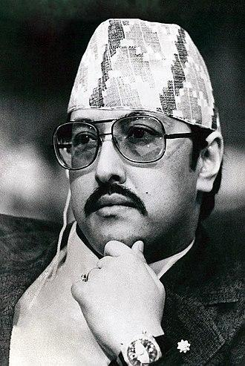

Birendra spent eight years studying at St Joseph's School, a Jesuit school in Darjeeling, with his brother Gyanendra. On 13 March 1955, their grandfather King Tribhuvan died and their father succeeded to the Nepalese throne. With his father's ascension, Birendra became the crown prince of Nepal.

## **Early Life:**

## Birendra was educated at St. Joseph’s College (Darjeeling, India), Eton College (England), Tokyo University (1967), and Harvard University (1967–68) and traveled extensively before acceding to the throne on his father’s death on January 31, 1972. (He was crowned on February 24, 1975.) Birendra continued the autocratic tradition of his father, who had dissolved the elected parliament in 1960 and banned political parties in the constitution of 1962; indeed, for a time, Birendra was one of the world’s few remaining absolute monarchs. He managed to maintain Nepal’s independence despite encroaching influences by India, China, and the Soviet Union. During his reign, Nepal was opened up to extensive tourism.

**GOOD WORKS OF KING BIRENDRA**

1. **International Relations**

I believe King Birendra was a nationalist whose main concern was the survival of the Nepali state more than anything. Under the rule of King Mahendra his father Nepal established diplomatic relations with many countries including China and steered a more independent foreign policy. King Birendra continued that by expanding diplomatic relations and under his reign Nepal even became a non-permanent member of the UN Security Council which was a major feat. So the first achievement I think is increasing the international profile.

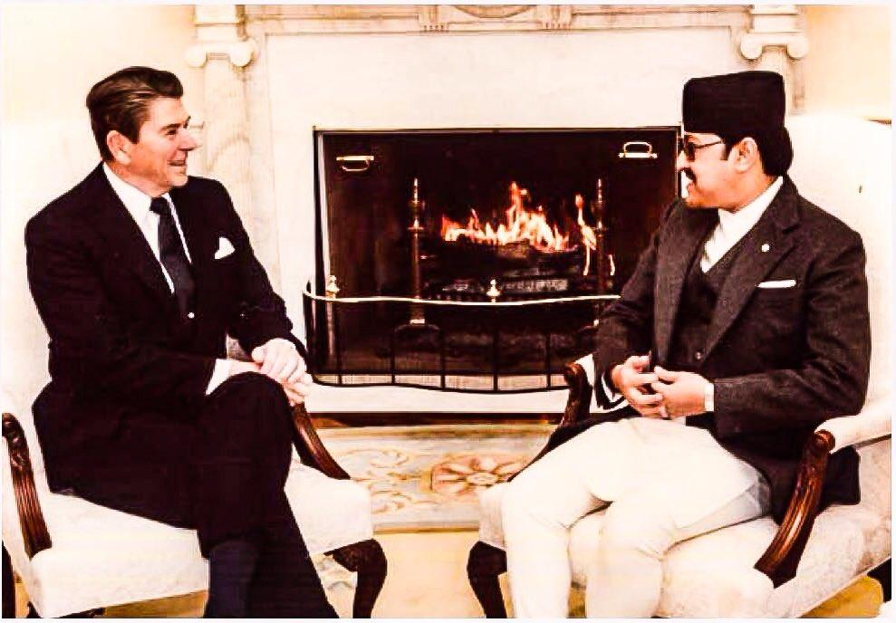

fig. President Ronald Regan and King Birendra

The second important thing is maintaining Nepal's independence and preventing it from being another Bhutan. FYI Bhutan is a country whose foreign policy is essentially run by India so much so that it hasn't even established diplomatic relations with China. Back in 1990 AD with protests in Nepal for democracy, the Indian govt launched a blockade of Nepal and then sent a secret treaty to King Birendra where his absolute rule was guaranteed by the Indian govt if he just agreed to hand over Nepal's natural resources and foreign policy to India just like Bhutan. He said No and then gave up power to the people rather than be an absolute ruler supported by India just like Bhutan. This I believe is very important because power corrupts absolutely and King Birendra thought about Nepal first, not his own personal power.

**Promotion of peace**

He proposed Nepal be declared a zone of Peace in the United Nations meeting, taking into consideration Nepal's historic peace status, the birth of Gautam Buddha, and its historical policy of Non-alignment to any foreign powers. This proposal was supported by 116 countries in the UNO. He later established a "Peacekeeping Training Camp" in 1986. This was later restructured into a training institute in 2001 for training peacekeeping forces. It was later renamed as Birendra Peace Operations Training Centre. This institute was later restructured as the training organization through which Nepal started sending trained, peace-keeping forces in cooperation with the UN and became an active member of it. In 1974, King Birendra was successful in peacefully disarming the Khampas rebellions, and settling in the northern Himalayan region, by giving land, money, and citizenship to those who surrendered their arms, and by confiscating weapons as well.

**Environmental protection**

King Birendra was regarded as a lover of nature and a great supporter of nature conservation. The trend of nature conservation from the government started during his reign. The dramatic decline of the rhinoceros population due to massive Terai migration and the extent of poaching prompted the government to institute the Rhino Patrol force (Nepali: गैडा गस्ती ) of 130 armed men and a network of guard posts all over Chitwan. To prevent the extinction of rhinos through a legal system, the National park law was introduced

**Roads and Transportation**

Various Studies in 1972 showed that building road connectivity in hilly and rural areas was more expensive than air connectivity. So, the then government took the policy of connecting rural areas with airports and built roads only when there was a high amount of traffic flow. Under this policy, Baglung Airport (Balewa Airport), Dhorpatan Airport, Mahendranagar Airport, and Rukum Chaurjahari Airport were established in the year 1973. Sanfebagar airport was established in 1975. Simikot Airport was established on 18th March 1977, Dolpa Airport was established in 1978, and Ramechhap airport in 1979. Doti Airport, also known as Silgadhi Airport, was established in 1973 with a blacktopped runway. Talcha Airport, also known as Rara Airport was built in 1975. Taplejung Airport located in Phungling, also called Suketar Airport, Jiri Airport, Phaplu Airport, and Bajhang Airport was built in 1976. Rolpa Airport in 1980, Manang Airport in 1981, Bajura airport in 1984, and Darchula Airport in 1986.

**The dark side of king Birendra's**

**Stagnant economy**

Though King Birendra is remembered as a development-friendly king, he is also criticized for his inability to drive the country towards rapid development efforts like his father King Mahendra. He had the political will but simply not the skill through which development efforts could be rapidly gained. His policy of sustainable development, shown by his nature conservation efforts, culture, and history became hindrances to economic development. The Panchayat regime created a stagnant economy during his reign as an autocratic ruler.

**Administrative failure**

Historians point out that the Panchayat Regime under King Birendra was a failure. He was not able to bring in much direct foreign investment during his reign, and all the programs he brought, or all the reforms he made were the continuation of his father's legacy. He restructured various organizations previously established by his father and implemented various development plans envisioned by his father. However, he was not able to bring about a radical change in the country. Moreover, some historians also claim that making the cannabis trade illegal, implemented during this era, created mass unemployment which eventually became one of the causes of the Maoist revolution.

**Failed development efforts**

Birendra restructured various organizations and brought many development plans, but his development efforts were mostly a failure; which hindered any radical change in the country. Many airports and roads built during his era were rarely used, and eventually had to be closed down.

**Conclusion**

In conclusion, King Birendra was a person who worked for the country and tried to improve it but some of his policies were quite ineffective. He had also conducted a referendum, which pro-Democrats stated unethical and fraud. He was also a reason for the removal of the panchayat and the establishment of a constitutional monarchy. He played an important role in the development of Nepal. He is still considered a good and moral King.

**References:**

<https://wikipedia.org>

<https://google.com>

<https://youtube.com>

<https://washingtonpost.com>